Mathematical Sentence

🌟 Definition
# Source: AI Source: Provided by: [Data Path: Persons Table -> ID Column: 1, Name_En Column: Motasem Essam] -> From: [ChatGPT] on [5/29/2026]
A mathematical sentence is a complete mathematical statement that expresses a fact, relation, or condition and has a definite truth value (it is either true or false).
Unlike an expression, a mathematical sentence is a full statement that can be judged.

🎯 Purpose of a Mathematical Sentence
# Source: AI Source: Provided by: [Data Path: Persons Table -> ID Column: 1, Name_En Column: Motasem Essam] -> From: [ChatGPT] on [5/29/2026]
- To express mathematical facts clearly
- To state conditions or relationships
- To form the basis of logic and proofs
- To describe properties of mathematical objects
- To communicate true or false statements

📚 Key Characteristics
# Source: AI Source: Provided by: [Data Path: Persons Table -> ID Column: 1, Name_En Column: Motasem Essam] -> From: [ChatGPT] on [5/29/2026]
A mathematical sentence:
- Is a complete statement
- Has a truth value (true or false)
- May contain variables
- Often includes symbols like =, <, >, ≤, ≥
- Can be evaluated or proven

🧩 Types of Mathematical Sentences

1. True Sentence
# Source: AI Source: Provided by: [Data Path: Persons Table -> ID Column: 1, Name_En Column: Motasem Essam] -> From: [ChatGPT] on [5/29/2026]
A statement that is always or currently true.
Example:
$$2+3=5$$

2. False Sentence
# Source: AI Source: Provided by: [Data Path: Persons Table -> ID Column: 1, Name_En Column: Motasem Essam] -> From: [ChatGPT] on [5/29/2026]
A statement that is not true.
Example:
$$7<3$$

3. Open Sentence
# Source: AI Source: Provided by: [Data Path: Persons Table -> ID Column: 1, Name_En Column: Motasem Essam] -> From: [ChatGPT] on [5/29/2026]
A sentence containing variables that is true or false depending on the value.
Example:
$$x+2=5$$
- True if x = 3
- False for other values

✏️ Examples of Mathematical Sentences
# Source: AI Source: Provided by: [Data Path: Persons Table -> ID Column: 1, Name_En Column: Motasem Essam] -> From: [ChatGPT] on [5/29/2026]
- 10 > 5 (true)
- 4 = 9 (false)
- x − 1 = 6 (open sentence)
- 3 × 2 = 6 (true)

🔗 Relationship to Other Concepts
# Source: AI Source: Provided by: [Data Path: Persons Table -> ID Column: 1, Name_En Column: Motasem Essam] -> From: [ChatGPT] on [5/29/2026]
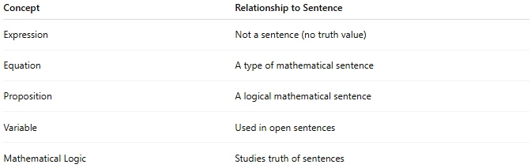
Concept | Relationship to Sentence
Expression | Not a sentence (no truth value)
Equation | A type of mathematical sentence
Proposition | A logical mathematical sentence
Variable | Used in open sentences
Mathematical Logic | Studies truth of sentences

📖 Sentence vs Expression vs Equation
# Source: AI Source: Provided by: [Data Path: Persons Table -> ID Column: 1, Name_En Column: Motasem Essam] -> From: [ChatGPT] on [5/29/2026]
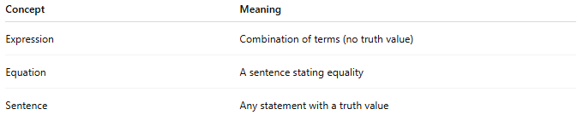
Concept | Meaning
Expression | Combination of terms (no truth value)
Equation | A sentence stating equality
Sentence | Any statement with a truth value
Example:
- Expression: $x+3$
- Equation (sentence): $x+3=7$
- True sentence: $5+2=7$

🧠 Simple Analogy
# Source: AI Source: Provided by: [Data Path: Persons Table -> ID Column: 1, Name_En Column: Motasem Essam] -> From: [ChatGPT] on [5/29/2026]
A mathematical sentence is like a statement in a courtroom:
- It claims something
- It can be judged true or false
- It must be clear and complete

🧭 Summary
# Source: AI Source: Provided by: [Data Path: Persons Table -> ID Column: 1, Name_En Column: Motasem Essam] -> From: [ChatGPT] on [5/29/2026]
A mathematical sentence is a complete mathematical statement that has a truth value—it is either true or false. It is used in logic, equations, and reasoning to express mathematical facts and relationships.

